Part 2: Data Relationships in MS Access
1. One-to-One Relationship
Definition: Each record in Table A relates to only one record in Table B.
Example: A Students table and a StudentProfile table (extra details like address, parent info, medical info).
Implementation in MS Access:
Set StudentID as PK in both tables.
Link them with a 1-to-1 relationship.
2. One-to-Many Relationship
Definition: One record in Table A relates to many records in Table B.
Example:
One Student can have many Enrollments.
One Course can have many Enrollments.
Implementation in MS Access:
In Relationships window, drag StudentID from Students to Enrollment.StudentID.
Choose Enforce Referential Integrity.
A “1” will appear on Students side and “∞” (many) on Enrollment side.
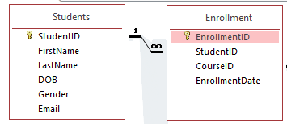
3. Many-to-Many Relationship
Definition: Records in Table A relate to many records in Table B, and vice versa.
Example:
Students enroll in many courses, and each course has many students.
Implementation in MS Access:
Achieved through a junction table (Enrollment).
So, Students ↔ Courses = Many-to-Many via Enrollment.
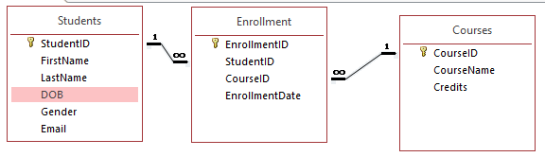
Importance of Referential Integrity
Ensures that relationships remain consistent.
Example:
You cannot enroll a student in a course if the student’s record does not exist in Students.
If you delete a student, all related enrollments can be set to delete automatically (cascade delete).
